Analysis of

Urban Heat Island effect with respect to City 3D Shapes

Project proposal & Statement of Work

Pradnya Raut,

Student of MS (Information Science – machine learning)

POTENTIAL ADVISORS: Dr. Cristian Román-Palacios

Date: 09, 17, 2024

|  |  |  |  |
| --- | --- | --- | --- |
| Revision History Table | | Template Date 6/15/2022 | |
| Version | Summary of Changes | | Date |
|  |  | |  |
| V2 | Update 1 Executive summary, Research section, Added Gantt Chart, surface water link | | 09/26/2024 |

Contents

1. Executive Summary 3

2. Literature Review/Market research 5

3. Research Project Deliverables 6

**What Analysis Is Being Run?** **6**

**What Accuracy Is Expected?** **6**

**What if the Analysis doesn't work?** **6**

**What if the Data Isn't Available?** **6**

4. Project Timeline & Gannt Chart 7

5. Ethics 8

6. Approvals 11

7. Appendix 12

A. Advisor Engagement 12

1) Project Team Responsibilities 12

2) Faculty Advisor Responsibilities 12

B. Ground Rules 12

# Executive Summary

We aim to explore how building shapes interact with urban policies and regulations. We plan to develop urban planning strategies aimed at mitigating Urban Heat Island effect as well as the impacts of climate change to urban areas. We exploreg the relationship between variables like urban morphology, building heights, vegetation, green distribution, shadow and the UHI effect/ climate change (H M Abdul Fattah, 2024, p2)

Research has shown that urban areas tend to have higher temperatures compared to the surrounding rural areas. This effect is known as the urban heat island (UHI) [1]. The temperature increase within urban areas is known to lead to various problems including human health issues, increase in energy consumption thereby increasing greenhouse gas emissions, as well as further contributions to climate change. To reduce these effects there is need to identify factors related to UHI and take appropriate actions to mitigate its effect in urban areas.

Work done by Mr. H M Abdul Fattah on this project [8] consisted of downloading city shape file, building height dataset, calculating city wise area vs building height distribution and classifying cities into one of the four categories. Dataset about the heights of buildings globally (GHS-BUILT-H - R2023A) was obtai ned from GHSL - Global Human Settlement Layer dataset[13] . Additionally, shapefiles, defining urban areas , were obtained from World Urban Areas, LandScan, 1:10 million (2012) [14] . Data of heights of buildings was filtered using shape files and analysed to find the distribution of building heights in the city. Based on the shapes of distribution (their skewness and dip statistic values), the shape of city was classified as unimodal right skew (Pyramid) shape, unimodal left skew (Inverse Pyramid) shape, or has no significant skew (Diamond) shape [15] [8]. In case of presence of multimodality, indicated by the dip statistic, shape was classified as "Hourglass." The "Pyramid" class signifies a concentration of shorter buildings, while "Inverse Pyramid" indicates a concentration of taller buildings. "Diamond" suggests a balanced distribution of building heights, while "Hourglass" implies varying patterns in building height distribution.

Work that needs to be done is getting UHI effects data for the year 2018 [9] and other variable data like green vegetation [10], solar radiation [11], surface water [12].Since the latest dataset available for building height is of year 2018, the rest of the datasets will also be downloaded for the same year 2018 wherever possible. It was possible to download full global UHI data with resolution of 3000m/pixel The resolution of building height dataset is around 30m/pixel whereas most of the datasets in googleearth engine are around 300m/pixel. Attempts can be made to improve resolution as close as 100 m or 3 ss as possible. This downloading can be done either using Javascript scripts in google earth engine or using geemap api in Python

Using shape file that define city boundaries, for each variable datafile, city data can be extracted into separate datasets, mean will be computed for cities. This task can be done using R program with the help of terra package Or using geemap api in Python.All these variable datasets of UHI, vegetation NDVI, solar radiation, surfacewater will be merged with the file containing shapes of city in R/python. Exploratory Data Analysis (EDA) analysis will be performed. Fit machine learning (ML) model and identify relationships between the selected variables and urban heat island(UHI) mean in python

|  |  |
| --- | --- |
| Team Member | Feature responsibility |
| Pradnya Raut | Obtaining data  Perform EDA, merge with the existing data files  Fit ML model  Report outcomes |

Table 1 Preliminary Subsystem Responsibilities

# Literature Review/Market research

Urban Heat Island (UHI) is impacting people in various ways. It leads to increased vulnerability to human health issues like heat strokes, exhaustion, suicidal tendancies. It is also impacting air quality due to more amount of pollutants released in air and poor scattering of these pollutants. Water quality also gets impacted due to increase in water tempaerature affecting native aquatic life.[2]

Urban areas are densely populated with more people. Closely constructed building and skyscrapers mean a lot of waste energy is emitted and can not escape the area. Increase in temperature also causes increase in energy consumption thereby increasing greenhouse emissions  for the city dwellers. [3].

According to David L. Chandler**,** Urban heat island effects also depend on a city’s street and building layout. Some cities, such as New York and Chicago, are laid out on a precise grid, like the atoms in a crystal, while others such as Boston or London are arranged more chaotically, like the disordered atoms in a liquid or glass. The researchers found that the “crystalline” cities had a far greater buildup of heat compared to their surroundings than did the “glass-like” ones.[4]

It is found that Urban heat island effect(UHI) is positively correlated with city area. Building materials which absorb and radiate heat back into the air gets trapped in the nearby vicinity in the area densely crowded with buildings instead of spreading out evenly[5]. Hence effect of heights of skyscrapers also needs to be studied apart from the area of city. This can help in planning for urban area expansions or in new urban area developments

According to Nyuk Hien Wong, Chun Liang Tan, Dionysia Denia Kolokotsa & Hideki Takebayashi [6],

Green infrastructure acts to cool the urban environment through shade provision and evapotranspiration. Typically, greenery on the ground reduces peak surface temperature by 2–9 °C, while green roofs and green walls reduce surface temperature by ~17 °C, also providing added thermal insulation for the building envelope. However, the cooling potential varies markedly, depending on the scale of interest (city or building level), greenery extent (park shape and size), plant selection and plant placement . This can be a tool for mitigating Urban heat island effect (UHI)

Climate change is impacting cities and their residents in many ways, from poor air quality to flooding, biodiversity loss and extreme heat. Mackres et al.  [7] with the help of a dashboard provides insight into connection between climate change and urban life. This can be useful for city designing in a more sustainable and nature-positive ways to mitigate climate change

# Research Project Deliverables

**Final Presentation Format**

Final Presentation will be in the form of a paper containing introduction, methods, result and will be placed on GitHub

**What Analysis Is Being Run?**

The dataset will be divided into training set and test set. Some classifier/regressor ML models like logistic regression, Decision Tree or Support Vector Machine will be fitted between types of cities, vegetation/green spaces, surface water vs UHI mean temperature as target variables for the training data and UHI temparature values are predicted using test data. Confusion matrix, recall, accuracy, precision, F1-score will be calculated for these models using test and training data. Using these measures, performance of these models is evaluated. Higher accuracy % means the models are able to predict accurately. Also by examining coefficiants, P-values statistically significant variables can be determined and dependancy of variables established.

**What Accuracy Is Expected?**

Accuracy > 60%

**What if the Analysis doesn't work?**

A null is acceptable. If analysis doesn’t work, there may be some other factors like road/building material, presence of industrial area which may be more dominant than the variables considered in the study

**What if the Data Isn't Available?**

Most of the data is available, Links to access the data are provided viz.

Urban heat Island dataset [9] , Normalized Difference Vegetation Index dataset [10], solar radiation dataset [11], Global surface water dataset[12]

# Project Timeline & Gannt Chart

|  |  |
| --- | --- |
| Milestone | Date |
|  |  |
| Team Formation | 09/12/24 |
| Project Proposal Draft | 09/21/24 |
| Signed proposal | 09/27/24 |
| Data Collection and preprocessing | 10/31/24 |
| Fit ML models | 11/30/24 |
| Team Formation | 09/12/24 |

Table 2: Milestone Schedule

Gannt chart for schedule.

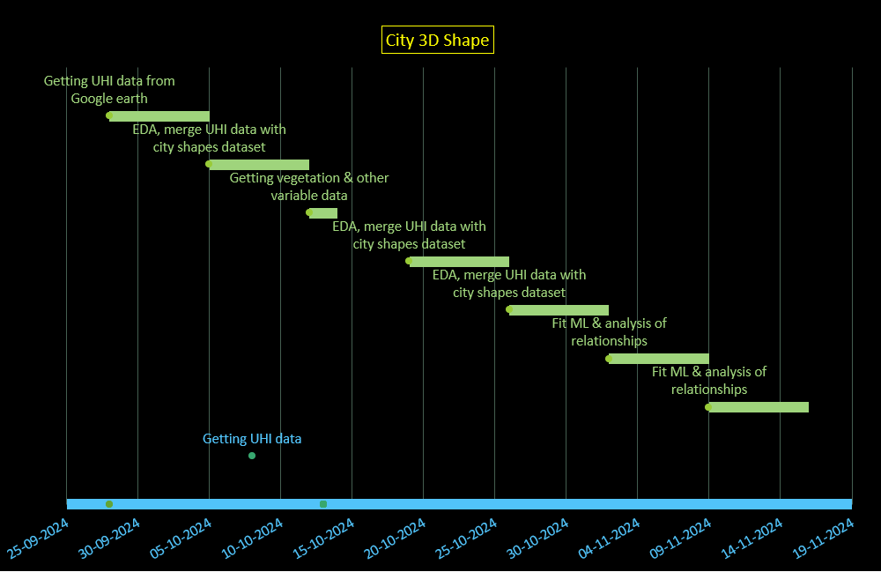

# Ethics

Table 3 Ethics

|  |  |  |  |
| --- | --- | --- | --- |
| **#** | **Question** | **Generally** | **Data Breach** |
| 1 | Could a user sell drugs or other illegal items on your platform? | N | N |
| 2 | Could a user of your platform engage in sex trafficking? | N | N |
| 3 | Could a user sell class notes or cheat on their homework on your platform? | N | N |
| 4 | Could a stalker use your project to find someone? | N | N |
| 5 | Could your app be used to spy on or track individuals? | N | N |
| 6 | Could your app/software access the camera or microphone and record things without users being aware? | N | N |
| 7 | If someone uses your platform, could they be re-traumatized or have their mental health impacted in some way? | N | N |
| 8 | Could your algorithm promote material that would traumatize or upset individuals? | N | N |
| 9 | Would your users be upset if the data you collect was given to someone else? | N | N |
| 10 | Could a data leak potentially lead to identity theft? | N | N |
| 11 | If your site was hacked, would users of that product potentially lose their job, spouse, or family? | N | N |
| 12 | Should there be an age limitation on your product? | N | N |
| 13 | Could someone use your product to find, contact, and potentially commit elder abuse? | N | N |
| 14 | If the data on your platform was breached, could it be used to blackmail the users? | N | N |
| 15 | Does the existance of your project imply that a particular racial group, gender, religion or other protected category is inherently bad, gross, or unwanted? | N | N |
| 16 | Could your product be used to commit hate crimes against a specific group? | N | N |
| 17 | Does the primary content of your game or algorithm focus on something considered deeply unethical? | N | N |
| 18 | Does your game or software contain race, gender, or other stereotypes? | N | N |
| 19 | Could users of your app scam other individuals? | N | N |
| 20 | Is your particular algorithm biased towards predicting correctly only for one race, gender, or other group? | N | N |
| 21 | Are the users of your project, players of your game, or those being surveyed for your data aware of how their data will be used? | N | N |
| 22 | What are the possible misinterpretations of your results? For example - would a white supremacist or misogynist be stoked about your results if they misinterpreted it? | N | N |
| 23 | Does the use or purchase of your data potentially contribute to a dangerous group or regime? | N | N |
| 24 | Could your virtual reality environment cause injury to the user? | N | N |
| 25 | Are your study participants or game players aware that their data will be collected and used? | N | N |
| 26 | Does your game or app contain addictive design elements without benefit to the user? | N | N |
| 27 | Does your survey contain an aspect of compulsion or unusually large incentive, that would command users to take it even if it was to their detriment? | N | N |
| 28 | Could your research outcomes harm an individual or entity? | N | N |

# Approvals

The signatures of the people below indicate an understanding of the purpose and content of this document by those signing it. By signing this document, you indicate that you approve of the proposed project outlined in this Statement of Work, the division of work, the Ground Rules and that the next steps may be taken to create a Product Specification and proceed with the project.

This document is based upon and supersedes the City 3D ShapeV1 Deviations, (versus clarifications), from the PDR have been clearly noted. For any requirements not listed in this SOW, the PRD requirements shall remain in effect.

|  |  |  |  |
| --- | --- | --- | --- |
| Approver Name | Title | Signature | Date |
|  |  |  |  |
| Pradnya Raut | Team Member | P.R. Raut | 09/27/2024 |
| Cristian Roman-Palacios | Advisor |  |  |
|  | Instructor |  |  |

Table 4 Approvers

|  |  |  |
| --- | --- | --- |
| Section | Author | Word Count |
| Executive Summary -Introduction | H M Abdul Fattah | *68* |
| Second paragraph | Pradnya Raut | 86 |
| Third paragraph | Pradnya Raut | 410 |
| 2. Literature Review/Market research | Pradnya Raut | 419 |
| 3.  Research Project Deliverables | Pradnya Raut | 226 |
| 4.  Project Timeline &Gannt Chart | Pradnya Raut | 34 |
| 5. Ethics | Pradnya Raut | 503 |
| 6. Approvals | Pradnya Raut | 180 |

Table 5 Word count

# Appendix

## Advisor Engagement

## Project Team Responsibilities

* The Project Manager will set up and facilitate a weekly call/meeting with the Faculty Advisor. The Project Team will provide weekly status updates to the Faculty Advisor including upcoming deliverables, critical issues, and any adjustments to the Project Plan.
* Documents will be provided to the Faculty Advisor with adequate time for review and signature. The time necessary for review will be agreed with the Advisor. The minimum review time will be 3 days prior to the document due date.
* Design files will be provided to the Faculty Advisor as requested in a format agreed to with the Advisor.
* Support requirements will be clearly requested from the Faculty Advisor with the dates required and an adequate time for fulfilling the request.
* Modifications requests to the Project Plan by Faculty Advisor will be reviewed and agreed to within 1 week of the request.

## Faculty Advisor Responsibilities

* The Faculty Advisor will provide knowledge and expertise to help the group stretch their skills.
* The Faculty Advisor will participate in a weekly or bi-weekly call/meeting with the Project Team to review the project status, upcoming deliverables, priorities, issues, and progress to the agreed Project Plan.
* The Faculty Advisor will provide document review, feedback and approval, rejection, approval with contingencies with adequate time for the Project Team to meet the course due dates.
* The Faculty Advisor will provide feedback to requested support requirements from the Project Team. This includes feedback and guidance on design implementations decisions, design files, test plans, test procedures and test results.
* The Faculty Advisor shall provide technical advice and guidance to the Project Team answering inquiries approximately 1 hour per week.
* Modifications to the Project Plan by the Project Team will be resolved and documented within 1 week of the request.
* Grade the finalized project using a skill-based rubric
* Attend iShowcase in May.

## Ground Rules

As a team and as individual team members, we agree to:

1. **Stay focused on our objectives and goals.**

Each time the team meets, we will clearly define our objectives and desired outcomes at the beginning of the meeting. We will politely remind team members if we are getting off track.

1. **“Sidebar” any issues that are relevant but not consistent with the immediate objectives.**

Occasionally, important matters are raised that are not relevant to the immediate goals of the meeting. To keep the group on track, but avoid losing the issue, create a “sidebar” where these topics can be listed and discussed later.

1. **Listen when others are speaking.**

We will listen and consider others’ input before adding our own comments.

1. **All viewpoints will have an opportunity to be heard.**

We understand that some team members may be quieter than others. We will make an effort to get each team member’s viewpoint and that no one dominates the discussion.

1. **Differences of opinion will be discussed respectfully**

We will identify areas of agreement before assessing areas of disagreement. We will encourage each other to look beyond our own point of view. We will discuss different ideas respectfully. As a team, we will weigh the merits of different opinions and agree on a process for choosing a direction. All team members will respect and follow the decision or direction.

1. **Look for the good points in new ideas.**

We will endeavor to explore the value in each idea as we assess and select our path forward.

1. **Focus on the future, not the past.**

We will use our past experience to inform our decisions, but focus the discussion on the future

objectives. Blame for past performance is counterproductive, we will focus on finding solutions.

1. **Agree upon specific action items and next steps.**

At the end of each meeting and discussion, we will summarize and agree on specific next steps, action items and assignments.

1. **Accountability**

As team members, we will each be responsible for our individual assignments and contribution to achieving the team objectives and goals. We will honor our responsibilities and not let our team members down.

**References**

[1] Urban heat island, Wikipedia, Available at <https://en.wikipedia.org/wiki/Urban_heat_island>

[2] Nidhi Singh, Saumya Singh, R.K. Mall. Urban ecology and human health: implications of urban heat island, air pollution and climate change nexus. Available at

https://www.sciencedirect.com/science/article/abs/pii/B9780128207307000173#:~:text=The%20UHI%20effect%20has%20caused%20an%20increase%20in,in%20nearby%20areas%20thus%20developing%20new%20ecological%20implications.

[3] Urban Heat Island (nationalgeographic.org) Available at <https://education.nationalgeographic.org/resource/urban-heat-island/>

[4] David L. Chandler, Urban heat island effects depend on a city’s layout, Available at <https://news.mit.edu/2018/urban-heat-island-effects-depend-city-layout-0222>

[5] City module - City cluster and urban heat islands (Europe), Available at

<https://www.pik-potsdam.de/cigrasp-2/city-module/heat-island-cluster/index.html>

[6] Nyuk Hien Wong, Chun Liang Tan, Dionysia Denia Kolokotsa & Hideki Takebayashi Available at

<https://www.nature.com/articles/s43017-020-00129-5>

[7] Mackres, E., Pool, J. R., Shabou, S., Wong, T., Anderson, J., Gillespie, C., & Alexander, S. New Data Dashboard Helps Cities Build Urban Resilience in a Changing Climate. Available at

<https://www.wri.org/update/new-data-dashboard-shows-climate-change-risks-in-cities>

[8] H. M. Fattah Capstone Report, Available at

<https://github.com/datadiversitylab/city-3D-shapes/tree/main/docs/Capstone_report_for_H_M_Abdul_Fattah.pdf>

[9] Urban Heat Island dataset,

Various UHI datasets available at

<https://developers.google.com/earth-engine/datasets/tags/uhi> or

YCEO Surface Urban Heat Islands: Pixel-Level Composites of Yearly Summertime Daytime and Nighttime Intensity available at

<https://developers.google.com/earth-engine/datasets/catalog/YALE_YCEO_UHI_Summer_UHI_yearly_pixel_v4> or

YCEO Surface Urban Heat Islands: Pixel-Level Annual Daytime and Nighttime Intensity available at

<https://developers.google.com/earth-engine/datasets/catalog/YALE_YCEO_UHI_UHI_yearly_pixel_v4>

[10] NOAA CDR AVHRR NDVI: Normalized Difference Vegetation Index, Version 5 dataset, available at

<https://developers.google.com/earth-engine/datasets/catalog/NOAA_CDR_AVHRR_NDVI_V5> or

MODIS Combined 16-Day NDVI available at

<https://developers.google.com/earth-engine/datasets/catalog/MODIS_MCD43A4_006_NDVI>

[11] MCD18A1.061 Surface Radiation Daily/3-Hour dataset, Available at

<https://developers.google.com/earth-engine/datasets/catalog/MODIS_061_MCD18A1>

[12] JRC Global Surface Water Mapping Layers, v1.4 dataset. Available at

<https://developers.google.com/earth-engine/datasets/catalog/JRC_GSW1_4_GlobalSurfaceWater>

[13] GHSL - Global Human Settlement Layer. Available at

<https://human-settlement.emergency.copernicus.eu/datasets.php>

(GHS-BUILT-H - R2023A dataset used for building height calculation)

[14] Kelso, N.V. and Patterson, T. (2012). World Urban Areas, LandScan, 1:10 million (2012). Available at

<https://geo.nyu.edu/catalog/stanford-yk247bg4748>

[15] Elsen, PR., & Tingley, MW. (2015). Global mountain topography and the fate of montane 296

species under climate change. Nature Climate Change, 5(8), 772-776 Available at

<https://www.nature.com/articles/nclimate2656>